**Install Packet Tracer**

In this course we will use a free utility developed by Cisco for training students in networking. The utility is called Packet Tracer. You can use this to explore network infrastructure in a way that would be difficult without a lot of equipment. Before we can explore this utility, you will need to download and install it. **PLEASE NOTE: If the instructions for this lab are slightly off (web pages do change!) then please observe the instructions on the site for guidance.**

**TASK A**

First, you will need to sign up for a course on the Cisco Networking Academy site:

1. Open a browser and navigate to **https://www.netacad.com/**

2. Select the **Courses** menu, and then click **Packet Tracer**.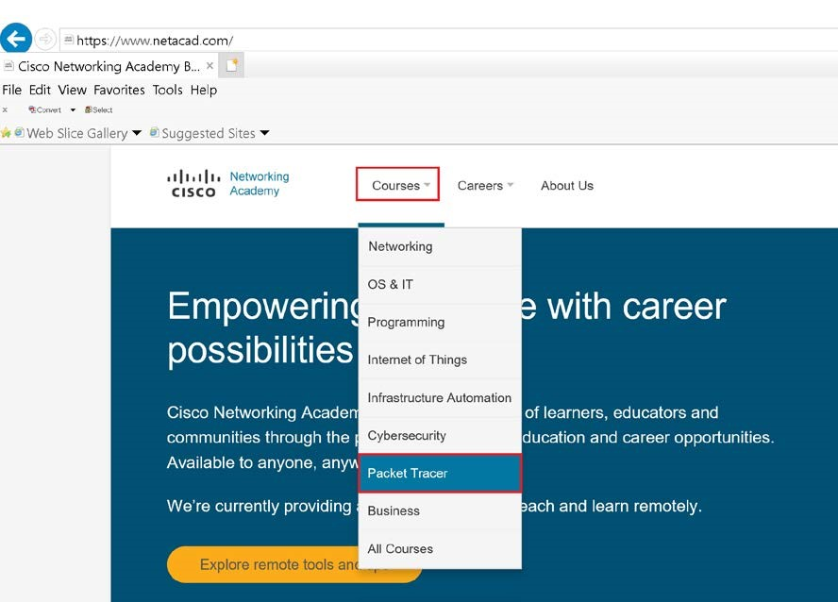

3. Click the **Introduction to Packet Tracer course** hyperlink.

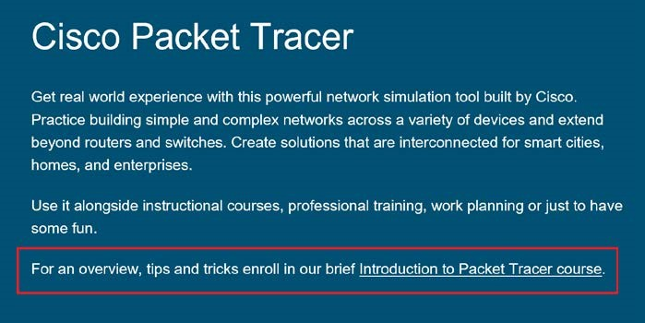

4. Click the **Sign up today!** button.

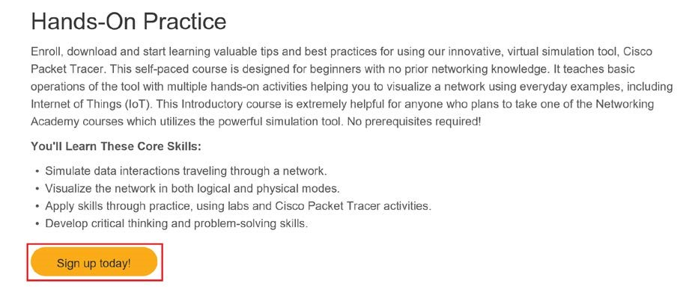

5. Follow the instructions to sign up for the academy.

6. Sign-in to the Academy.

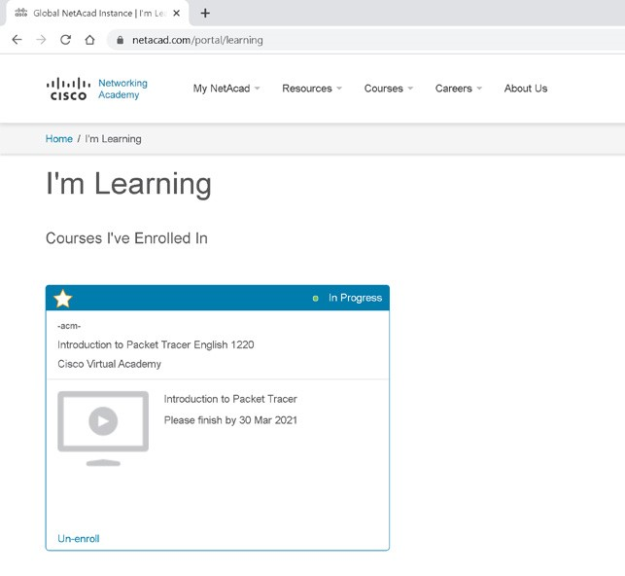

**TASK B**

Next, you will need to download the Packet Tracer software:

1. From the **Home** page of your academy account, open the **Resources** menu, and then click **Download Packet Tracer**.

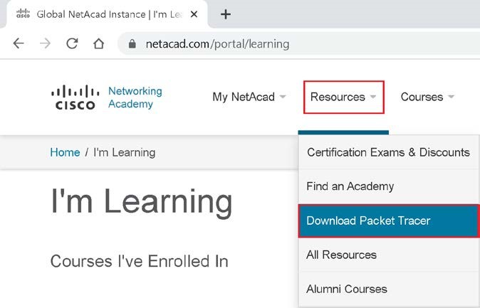

2. On the **Download Cisco Packet Tracer** page, scroll down and select the appropriate version to download.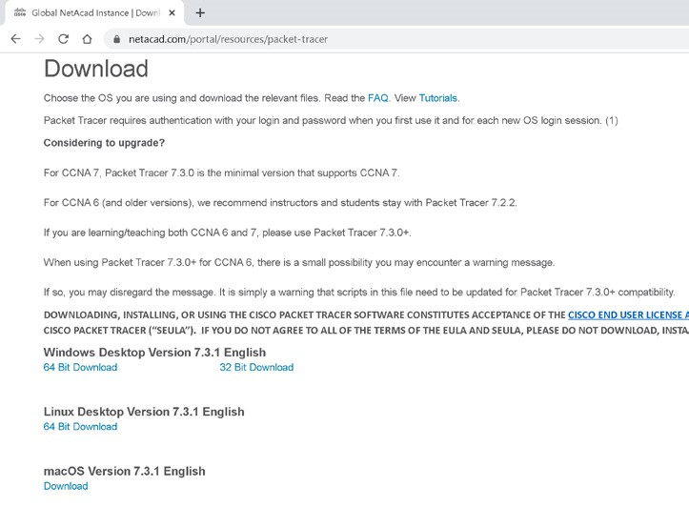

**TASK C**

Once you have downloaded the software, it needs to be installed. (NOTE: You are installing the software with all of the default options.)

1. Double-click the file you downloaded.

2. In the **License Agreement** dialog box, click the **I accept the license** radio button, and then click **Next**.

3. In the **Select Destination Location** dialog box, click **Next**.

4. In the **Select Start Menu Folder** dialog box, click **Next**.

5. In the **Select Additional Tasks** dialog box, click **Next**.

6. In the **Ready to Install** dialog box, click **Install**.

7. Click **Finish**.

8. If the application doesn't launch, start the **Packet Tracer** application.

9. In the **Would you like to run multiuser when application starts** dialog box, click **Yes**. If you get a firewall alert, click **Allow access**.

10. When prompted, log into your academy account. The **Packet Tracer** window should now appear.